**Association between cooperative strategies and genetic variability in oxytocin receptor (*OXTR*), arginine vasopressin receptor 1a (*AVPR1*) and monoamine oxidase A (*MAOA)* genes**

María Ignacia Rivera,1 Carlos Rodríguez-Sickert,1 Ricardo Andrés Guzmán1, Tadeo Ramírez,1 Felipe Benavides,2 Víctor Landaeta1 and Gabriela Repetto 2,3.

(1) Centro de Investigación en Complejidad Social (CICS), Facultad de Gobierno, Universidad del Desarrollo, Santiago, Chile. (2) Centro de Genética y Genómica, Facultad de Medicina, Universidad del Desarrollo, Santiago, Chile. (3) Facultad de Medicina, Universidad del Desarrollo, Santiago, Chile.

**Abstract:** Heterogeneity in cooperative behavior among humans have been well evidenced in real-life settings as well as in the lab. However, there is still poor understanding about the role played by genetic variability in shaping the diversity of cooperative strategies. We selected genetic polymorphisms based on existing evidence to explore the potential of genetic variability to explain this observed heterogeneity. We operationalized cooperative strategy as the scheme of contingent contributions displayed in a strategic public good game and explore its association with variants of the rs53576 *OXTR*, RS3 *AVPR1* and u-vntr *MAOA* polymorphisms in a sample of 200 undergraduate students. Our results show that men homozygous for GG in rs53576 *OXTR* tend to display cooperative strategies that cannot be classified within the more traditional ones.No association among the displayed cooperative strategies and genetic variability for the rest of the studied polymorphisms.

**Introduction**

The scale and sophistication of cooperation among non-relatives is unique to the human species. From food acquisition to defense, and from hunter-gatherer societies to industrialized nations, cooperation is essential for the achievement of collective goals and lies at the foundation of human social institutions. In despite of its universality among humans, the field of behavioral economics has shown through real life observations and economic experiments in social dilemmas the diversity of human cooperative behavior (1–4). Subjects seem to apply different strategies based on their own preferences and their beliefs about other’s behavior in specifics contexts (5–7). Although most people adhere to the social norm of conditional cooperation (i.e. cooperate if the others cooperate) in the context of social dilemmas, deviations to this behavior have also been evidenced. For example, some people chose to always free ride independent of what the rest of the people influencing the outcome do (1). Moreover, some have argued the existence of a “cooperative phenotype” which is domain general and temporal stable (8).

Economists have traditionally linked variation in social behavior to environmental factors but, the influence of biological variability on such heterogeneity has been explored more recently (9). Twin and family studies have shown that social characteristics such as empathy, altruism, sense of equity and trust are partially inheritable (10). In addition, a growing body of evidence, accruing from animal models to humans, has delineated the role that neurochemical pathways play as a source of individual differences in social behavior. Particularly, the influence of oxytocin (OXT) and arginine vasopressin (AVP) in affecting social behaviors have been strongly evidenced across the animal kingdom.

OXT and AVP are nonapeptides, highly conserved molecules comprised of nine amino-acids that function as both neurotransmitters and neuromodulators and exert their effects both centrally and peripherally in a sex-specific manner (11). Nonapeptides closely related to OXT and AVP have been shown to influence social behaviors in animals distantly related to humans, such as male copulatory behavior in species of mollusks, flock size in birds, and mating behavior in fish (12–14). In mammals, OXT and AVP have been directly implicated in social behavior like maternal behavior in rats, and pair bonding behavior in female prairie voles (15–18). Taken together, these results point towards OXT, AVP and the neural networks they affect as presumably relevant in the variation observed in human social behavior including cooperation. Indeed, much research in the past decade has come to support this suspicion. In humans, the influence of OXT on prosocial behavior have been heavily evidenced. Previous studies have shown that endogenous OXT levels rise after receiving greater signals of trust and experiencing higher levels of empathy, with subsequent increases in trustworthiness (19) and generosity (20), respectively. Similarly, intranasal administration of OXT have proved to increased trust (21) and altruistic behavior (22–24). While the administration of AVP have been associated to increased levels of cooperation among men in an iterated Prisoner’s Dilemma game (25).

Another biomolecule that have been implicated in a variety of human social behaviors and disorders is monoamine-oxidase A (MAOA), a neuro-enzyme that degrades norepinephrine, serotonin and dopamine in the brain. Manipulation of endogenous levels of the molecules degraded by MAOA have also been related to decision making like learning about bad decision outcomes and social choices involving affiliation and notions of fairness (26). Moreover, reduction of central serotonin activity, have been showed to diminish the probability of cooperative responding given mutually cooperative behavior in the past in an iterated Prisoner’s Dilemma game (27) and to induce a bias toward aggressive harvesting behaviors in a repeated common pool resource game (28).

More recently, studies are aimed to identify specific polymorphic genes that underlie the action of these neuropeptides. Correlational studies of polymorphisms in the genes coding for OXT and AVP (receptors *OXTR* and *AVPR*, respectively) as well as the gene coding for *MAOA* have proven fruitful avenues of study (see Aspé-Sánchez et al., 2016 for a complete review of *OXTR* and *AVPR*). The rs53576 single nucleotide polymorphism (SNP) of the *OXTR* gene has been associated to several social traits and neurological functions related to cooperation. When compared to carriers of the A allele (AA, AG genotypes), individuals homozygous for the G allele, which displays a guanine on the rs53576 position of an intron of the gene, show higher levels of empathy (29), positive emotions (30), sociality (31) and higher levels of pro-social responses to strangers in need (32). Moreover, these individuals are judged to be more prosocial by external observers of social interactions (32).   
In addition, the rs53576 polymorphism has been linked to diverse neurological effects that could underlay its observed influence on behavior, such as differential activation of the amygdala during emotionally salient cues and anatomical differences in key oxitocynergic regions in males, particularly in functional connectivity of the hypothalamus (33).

Length polymorphisms of the RS3 promoter region in the *AVPR1a* gene have also been correlated to variability in social traits. One study classified alleles in short and long categories, and showed that carriers of long alleles allocated significantly more funds in the Dictator Game (34). Later work then showed that children carrying a specific allele with a 327bp-long promoter donated significantly fewer funds in the Dictator game (35). Genetic variability on the *AVPR1a* gene has also been associated to neurological functions associated to social cognition. Male carriers of long RS3 AVPR1a alleles showed greater pre-pulse inhibition, a neurological function where a weaker preceding stimulus inhibits the reaction to a subsequent greater one; an ability essential to the effective analysis of a wide variety of environmental stimuli, including social cues (36). Additionally, recent work showed that males with relatively short repeats allocated less money to others in a Dictator game and exhibited a significantly smaller gray matter volume in the right fusiform face area compared with male long homozygotes (37). These results suggest that *AVPR1A* RS3 variants might affect altruistic behavior by modulating the gray matter volume of relevant brain areas involved in the processing of social information like the fusiform face area.

The efficiency of transcription of *MAOA* is influenced by a variable number of tandem repeats located in the promoter-region of *MAOA* (u-VNTR). This leads to two variants of the gene, one of low expression (*MAOA-L*) and one of high expression (*MAOA-H*) (38). In previous studies, *MAOA-L* has been found to be associated with antisocial behavior such as violence in maltreated children (39,40) and aggression after provocation in men (41). Several brain imaging studies were also able to link the *MAOA* length promoter polymorphisms to brain structure and functioning. More specifically, individuals carrying *MAOA-L* variant have been identified as presenting significant limbic volume reductions and hyperresponsive amygdala during emotional arousal, with diminished reactivity of regulatory prefrontal regions (42). It has also been observed that in men, *MAOA-L* predicted hyperresponsiveness of the amygdala and increased functional coupling between it and the ventromedial prefrontal cortex associated to increased harm avoidance and reduced reward dependence (43). Some of these brain areas are involved in emotion processing and social cognitive functions such as theory of mind, empathy, moral reasoning and social decision making.

In despite of the promising evidence pointing these polymorphism as linked to cooperative behavior, some studies have been unable to replicate its association (34,35). One reason behind this replicability problem may have to do with the fact that different methods for elicit cooperation can involve different neurological functions and subsequently, association with different genes. As an example, cooperation in a repeated game can be affected by learning processes within the game, while cooperation in a one-shot game cannot. If candidate genes have an effect over cooperation by shaping the learning processes involve in a game, we will only observe an association between a genotype and cooperative behavior in the repeated game but no tin the one-shot one. Therefore, there is a need for better decomposed the cognitive and emotional phenomena behind cooperative behavior to then, study its association with genetic variability. In an attempt to do that, this study explores the association of cooperative preferences and genetic variability by looking into cooperative strategies as elicited in a strategic public good game. This experimental method helps to elicit pre-dispositions to cooperate before any real interaction with others occurs (1).

Until today, only *MAOA* u-VNTR has been directly associated to variability in cooperative strategies. One recent study employed repeated Public Good Game experimental set up, where individuals were put in anonymous groups and had to decide through 10 rounds how much of their own funds to allocate to a “public project” that multiplies such funds by a factor to the split them in equal parts. The study showed that carriers of the low-expressing variants of the *MAOA* gene contributed significantly fewer funds to the public good in the first stages of the game, where there was little or no information about the contributions of other subjects (44). A subsequent study by the same team, using the strategy method -where an individual’s payoffs can be determined by their reported expected contributions for all possible average contributions of the other players- found that females with *MAOA-L* are less likely to behave like weak free-riders than *MAOA-H* carriers, whereas among males, the results did not show a significant association between genotype and player type (45).

Based on the previous evidence relating *OXTR*, *AVPR1a* and *MAOA* to prosocial behaviors with presumably much overlapping neuro-psychological architecture, we aimed to explore the association between genetic variability in these three candidate genes and heterogeneity in cooperative strategies, as elicited in a strategic public good game. Considering the existing evidence on genotypes and prosocial behavior, we predict that GG genotypes for rs53576 in *OXTR*, homozygotes for long alleles of RS3 in *AVPR1a* will be less likely to display less cooperative dispositions (i.e. free rider) relative to other genotypes. In the case of *MAOA* u-VNTR we look to replicate previous findings by Mertins et al., 2013. To test our hypothesis, 200 undergraduate students participated in a public good game with strategic method, and saliva samples were collected to obtain the genotypes each of them carried. We, then, looked for associations between displayed cooperative strategies and each of the polymorphisms studied.

**Methods**

*Behavioral data*

Behavioral data were collected in 10 experimental sessions in a computer room in Universidad del Desarrollo, Santiago, Chile. In each session, 20 undergraduate students, between 18 to 25 years old, seat in front an individual computer and listened the game’s instructions (**Appendix 1**). After the explanation, questions were answered aloud to improve the understanding of the game. Once no more questions were asked, each person play individually in his/her computer and communication was not allowed during the game.

In the game, each subject was endowed with 20 tokens and should decide how many of those tokens contribute to the public good and how many keep for themselves. Contributions to the public good were duplicated and divided in equal parts among the four members in the group, regardless of how many each member contributed. This game structure leads to the following payoff function:

$$π_{i}=20- g_{i}+0.5\sum_{j=1}^{4}{g_{j}}$$

With $π_{i}$ being the final payoff of subject *i*, $g_{i}$ $∈$ {0,1, …, 20} is the contribution of individual *i* to the public good and $g_{j}$ $∈$ {0,1, …, 20} is the contribution of each member of the group. As the marginal gain of contributing one toke to the public good is 0.5 while the marginal gain of keeping it in the private account is 1, we expect no contributions to the public good under the assumption of self-interested money maximizing individuals. We applied the same protocol as Fischbacher et al., 2001, in which subjects are asked to make two types of decisions; an unconditional contribution and a conditional contribution (1). Unconditional contribution is the answer to the question: You have 20 tokens; how many tokens will you contribute to the public good? This question does not provide the subject with any information about what other members of the group are contributing, thus this decision involves individual expectations. Instead, the conditional contribution requires the subject to fill a table in which he/she answers how many, from his/her 20 tokens, would contribute to the public good given the scenario in which the other members of the group contribute an average of x tokens (rounded to the integer), with x $∈$ {0,1, 2…20}. The answer to this question elicit cooperative strategies avoiding the confounding effects of intertemporal strategies or beliefs about others cooperative behavior.

After every subject have completed their contribution decisions, subjects were randomly matched in groups of four. The unconditional contribution of three random players in the group were averaged and this average contribution (rounded to the integer) was employed to find the conditional contribution of the fourth player based on his/her contribution table, this provide the total contribution to the public good within the group and individuals payoffs can be calculated. This procedure ensures that both answers can be considered as potential contributions to the public good when individual payoffs are calculated to motivate subjects to take both type of decision seriously.

The answers of each individual were recorded under an identification code. Before leaving the room, subjects were asked to provide a saliva sample in a tube labeled with their individual code. Finally, subjects collected their profits in a separate room.

*Genetic data*

Saliva samples were collected using the commercial kit of 23andMe ® and taken to the lab to genotype the polymorphisms of interest and gender in each sample.

*Statistical analysis*

ID codes from the game were matched with ID codes from the lab to obtain a database containing the behavioral responses and genetic information of each subject. The initial sample were 200 observations but 12 were lost due to problems with DNA extraction, leaving the final database with 188 independent observations.

We classified cooperative strategies based on subjects’ conditional contribution schemes. First, subjects whose maximum entry were below or equal to 20 % of the total endowment (4 tokens) were considered as free riders (FR). For strategies that did not enter the FR category, we run Spearman’s rank correlations between subject’s contribution and the hypothetical average contribution of the other members of the group by including each entry of the conditional contribution table sequentially. Not FR were classified as hump shaped (HS) if they showed at least one positive to negative change in the sign of their Spearman correlation coefficient (α< 0.001). Remaining subjects, were classified as conditional cooperators (CC) if they displayed a positive spearman coefficient (α< 0.001). Finally, subjects that do not enter in either of the previous categories were classified as other (OT). To test the robustness of our results, we applied different criteria of 10% and 30% of the total endowment as free rider’s cutoffs as well.

Genotypes for OXTR rs53576 were coded as GG, GA and AA. While alleles for AVPR1a RS3 microsatellite were coded as short if they have between 324 bp to 341 bp and as long if they have between 342 bp to 356 bp. This threshold was established to ensure that both sample groups were balanced (**Appendix 2**). This classification leaves us with three possible genotypes for the AVPR1a RS3 polymorphism: Short/Short, Short/Long and Long/Long. Our genetic analysis revealed four alleles for u-VNTR *MAOA* presenting 3.5, 4.5, 5.5 and 6.5 repeats (**Appendix 3**). These alleles correspond respectively to the 3, 4, 5 and 6 repeats alleles observed in previous studies (46). Given the low frequencies of the 5.5 and 6.5 repeats alleles in our sample we excluded their carriers from the analysis for this gene. Since the *MAOA* gene is in the X chromosome, men only present one allele for u-VNTR *MAOA*, therefore we have two genotypes for men: 4.5 and 3.5 repeats, equivalent to the high and low expression variants respectively. In the case of women, one of the two X chromosomes in somatic cells becomes transcriptionally inactive early in development (47). Because of this, we cannot know which of the alleles is being expressed in women that are heterozygous for u-VNTR *MAOA*, therefore we excluded them from the analysis. This lead us with two analyzable genotypes for women: 4.5/4.5 and 3.5/3.5 repeats, equivalent to the *MAOA-H* and *MAOA-L* variants respectively.

Association between genotypes and cooperative disposition displayed in the game were tested using a fisher exact test. We also applied a multinomial logistic regression models with bootstrapped standard errors and analyzed the resultant marginal effects to study in more detail the relationship between cooperative dispositions and genotypes. We corrected for multiple hypothesis testing using a Bonferroni correction since we use six different multinomial logistic models, which lead to a significance level of α = 0.008.

**Results**

*Behavioral results*

The distribution of cooperative dispositions for the different classification criteria are presented in **Table 1a** for women and in **Table 1b** for men. No significative difference was observed between the distribution of cooperative strategies between women and men (p ≥ 0.544, Fisher exact test). The shape of the average contribution profile obtained for each type of contribution strategy is shown in **Figure 1**. CC profile shows a self-serving bias, meaning that persons that display this cooperative disposition tend to contribute less than the others do on average.

**Table 1a**. Percentage distribution of strategies among women by the different classification criterion.

|  |  |  |  |
| --- | --- | --- | --- |
|  | Free rider cutoff criterion | | |
| Strategy | 10% of the endowment | 20% of the endowment | 30% of the endowment |
| Free rider | 3.74 | 9.35 | 17.76 |
| Conditional cooperator | 47.66 | 44.86 | 41.12 |
| Hump shaped | 12.15 | 12.15 | 10.28 |
| Other | 36.45 | 33.64 | 30.84 |

**Table 1b**. Percentage distribution of strategies among men by the different classification criterion.

|  |  |  |  |
| --- | --- | --- | --- |
|  | Free rider cutoff criterion | | |
| Strategy | 10% of the endowment | 20% of the endowment | 30% of the endowment |
| Free rider | 7.41 | 9.88 | 20.99 |
| Conditional cooperator | 54.32 | 54.32 | 45.68 |
| Hump shaped | 11.11 | 11.11 | 11.11 |
| Other | 27.16 | 24.69 | 22.22 |

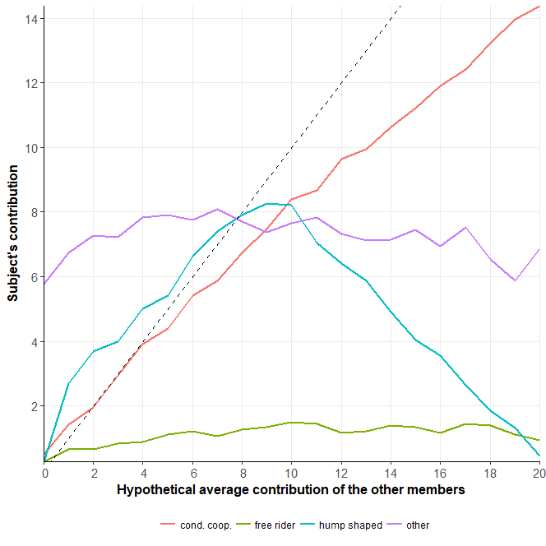

**Figure 1.** Average contribution profiles for each type of strategy classified under the 20% endowment Free rider cutoff criterion (n= 188). Free riders (green), Conditional cooperators (red), Hump shaped (light blue) and Others (purple). Dashed line represents the contribution profile of a perfect conditional cooperator.

*Genetic results*

The frequencies of the different genotypes obtained and the number of samples that could not be amplified or that were excluded for each polymorphism, are display in **Table 2a** for women, and in **Table 2b** for men.

**Table 2a**. Genotypes distribution for the three studied polymorphisms among women.

|  |  |  |  |  |  |
| --- | --- | --- | --- | --- | --- |
| *OXTR* rs53576 | n | *AVPR1* RS3 | n | *MAOA* u-VNTR | n |
| GG | 48 | Long/Long | 29 | 3.5/3.5 repeats | 9 |
| GA | 38 | Long/Short | 42 | 3.5/4.5 repeats | 41 |
| AA | 18 | Short/Short | 35 | 4.5/4.5 repeats | 38 |
| Not amplified | 3 | Not amplified | 1 | Not amplified or excluded by rare | 19 |

**Table 2b**. Genotypes distribution for the three studied polymorphisms among men.

|  |  |  |  |  |  |
| --- | --- | --- | --- | --- | --- |
| *OXTR* rs53756 | n | *AVPR1* RS3 | n | *MAOA* u-VNTR | n |
| GG | 40 | Long/Long | 13 | 3.5 repeats | 31 |
| GA | 29 | Long/Short | 38 | 4.5 repeats | 40 |
| AA | 9 | Short/Short | 28 | - | - |
| Not amplified | 3 | Not amplified | 2 | Not amplified or excluded by rare | 10 |

*Behavior and genetic association*

There was no significative difference in the distribution of cooperative strategies among sexes (p=0.544**,** Fisher exact test, two sided).Yet, we proceed with our analysis separately for each sex since previous literature have suggested sex specific effects. **Figure 2** shows the percentage of the subjects with each genotype displayed the different cooperative strategies. No association was found for any of the polymorphisms with cooperative dispositions, neither among women nor men (p ≥ 0.145, Fisher exact test, see **Appendix 4** for specific values). In despite of that, the multinomial logistic model revealed that being homozygous for GG increases the predicted probability of being classified as an OT in a 35% relative to AA genotypes in men (dy/dx = 0.350 SE=0.11, p=0.002). Although, no other significant effects were found for any of the other polymorphisms over cooperative strategy neither for women nor men (**Appendix 5 and 6**), we can still observe some patterns. For example, women presenting short and long alleles for *AVPR1a* RS3 seem to behave more as HS than the other genotypes. Men carrying two copies of long alleles in *AVPR1a* RS3 were never classified as FR in our sample. In the same way, women homozygous for MAOA-L in *MAOA* u-VNTR were never classified as HS.

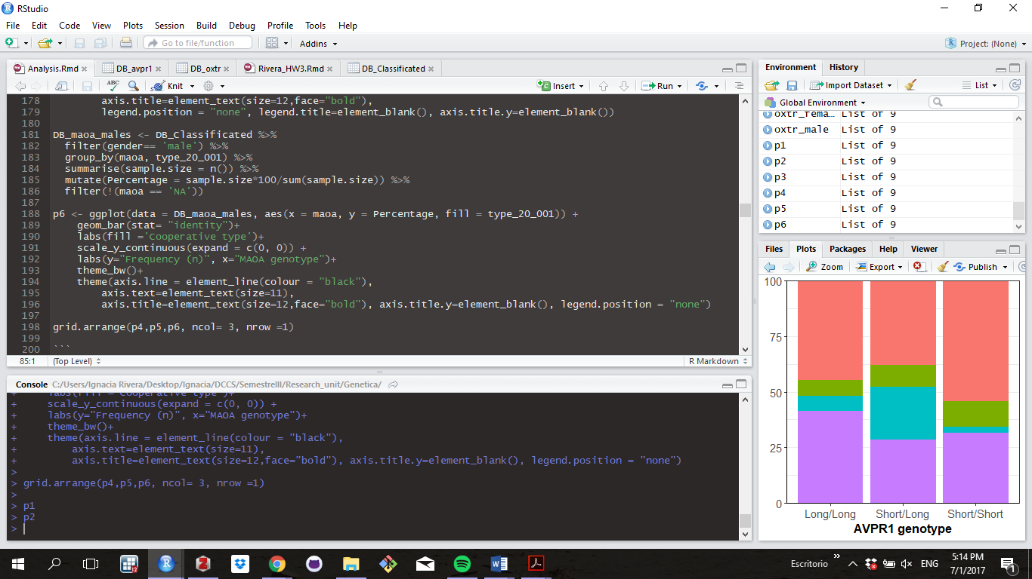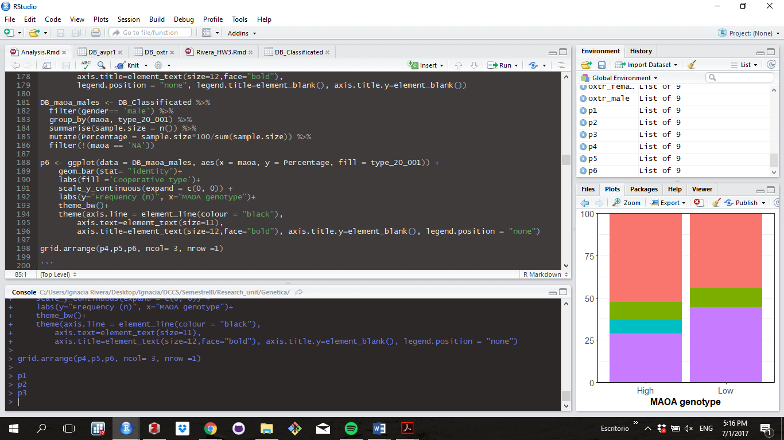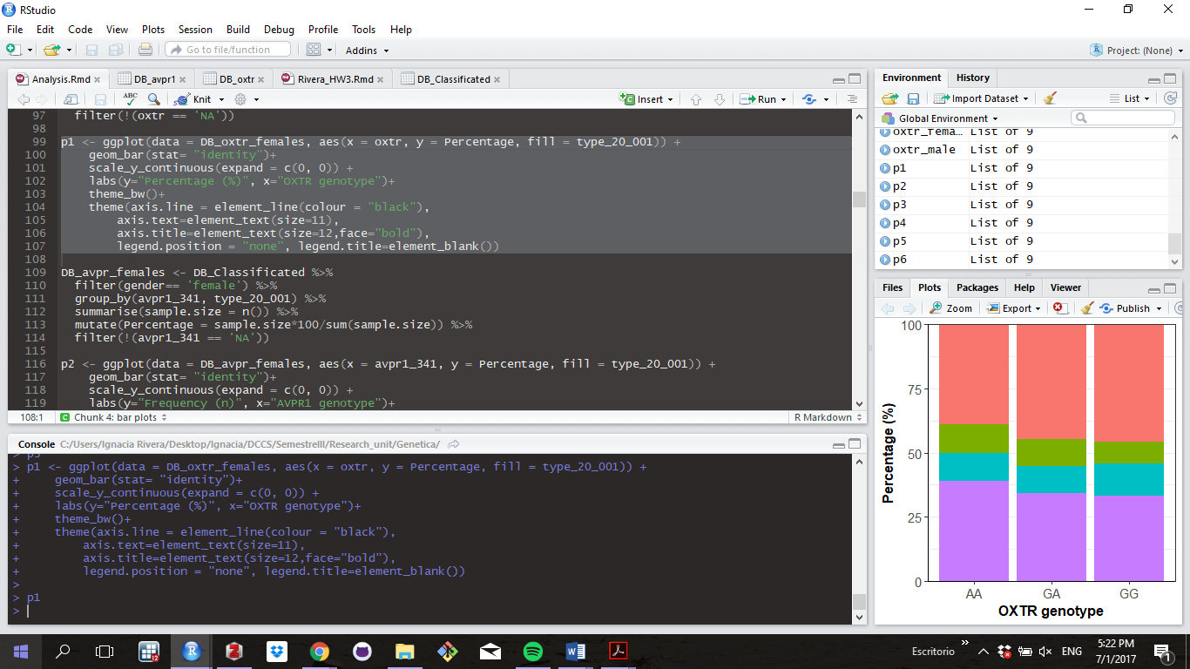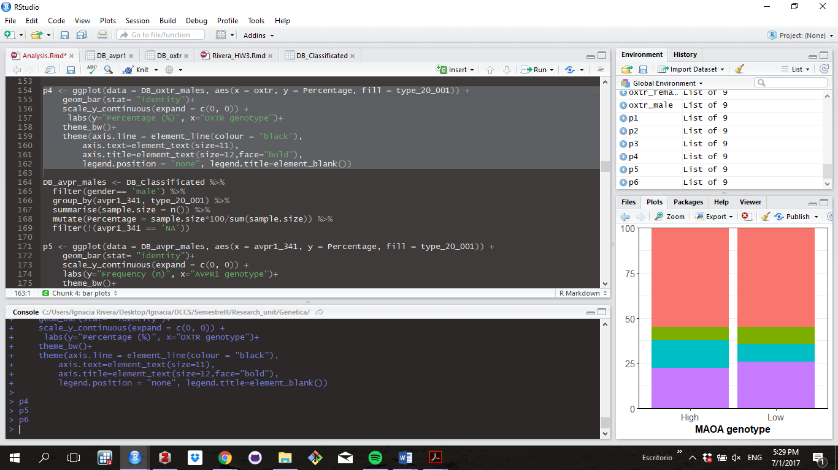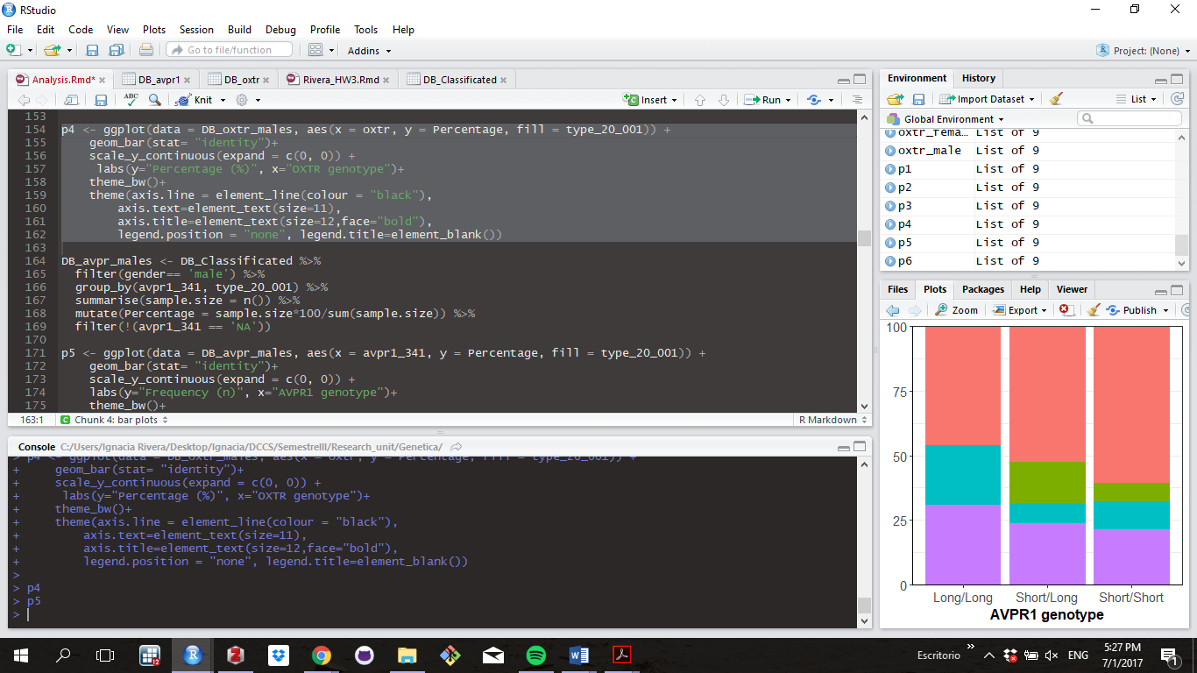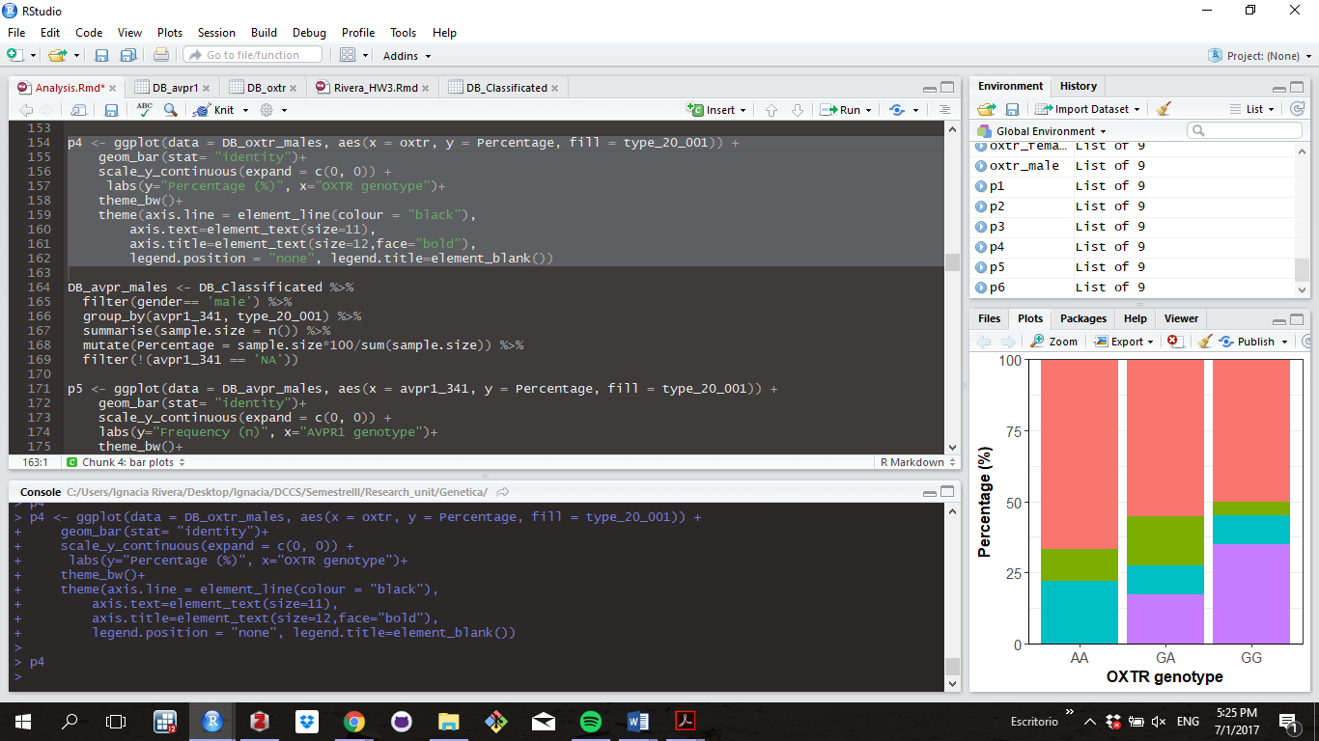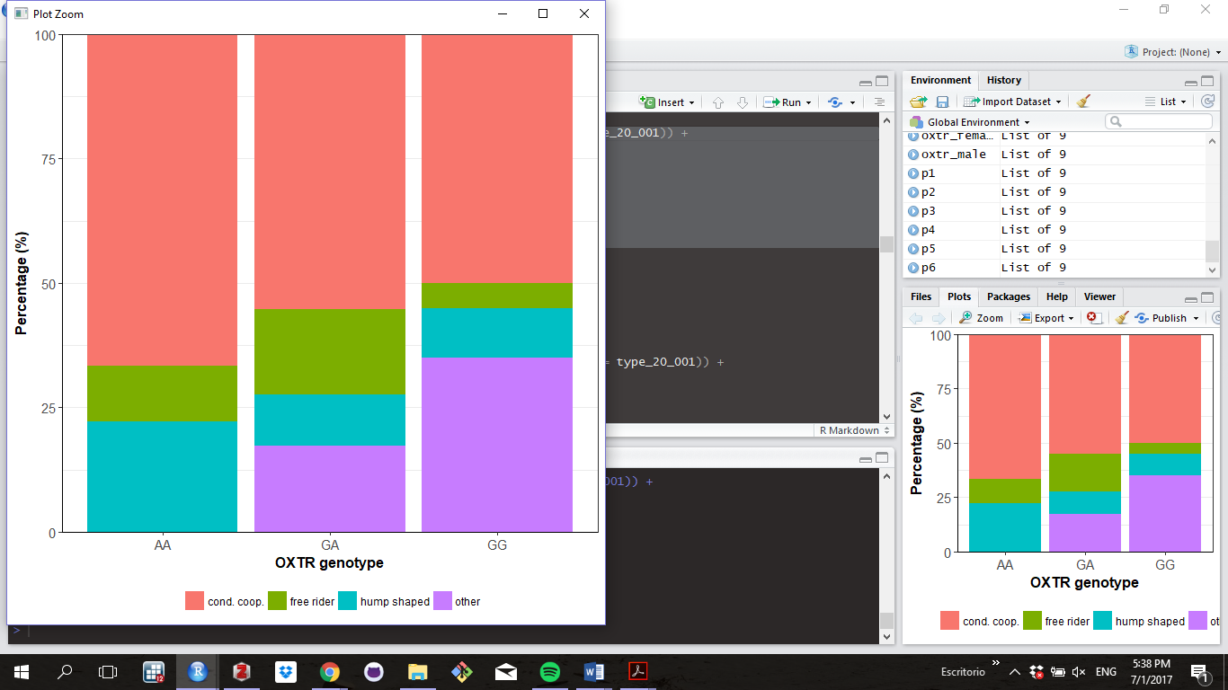

**Figure 2.** Distribution of cooperative preferences, conditional cooperators (in red), hump shaped (in cyan), free riders (in green) and others (in purple), among different genotypes for each of the studied polymorphisms in women (above) and men (below).

To explore cooperative strategies in a more continuous manner, we looked at the contribution profiles of different genotypes for each studied polymorphism in each sex (**Figure 3)**. For *OXTR* rs53756, AA women seems to contribute more in mid contribution scenarios, while men carriers of the G allele are more cooperative in low contribution scenarios compared to AA genotypes. Females carrying long and short copies for *AVPR1a* RS3 reduce their levels of contribution once the average level of contribution of the other members reaches approximately 9 tokens, relative to the homozygous types. Among men, the carriers of a short allele in *AVPR1a* RS3 seem to contribute always more than long/long genotypes. Women carrying the low expression variant of *MAOA* u-VNTR display higher contribution levels in low cooperation scenarios relative to MAOA-H. In the case of men, MAOA-L carriers show higher contribution levels than MAOA-H carriers in scenarios of high contribution by the other members of the group. The only significant difference in contribution levels among genotypes was found for *AVPR1a* in women for high contribution scenarios (*X*2= 7.24 and p = 0.025, Kruskal-Wallis rank test), when we classified others’ contribution in three scenarios: low cooperation scenario (from 0 to 6), mid contribution scenario (from 7 to 13) and high contribution 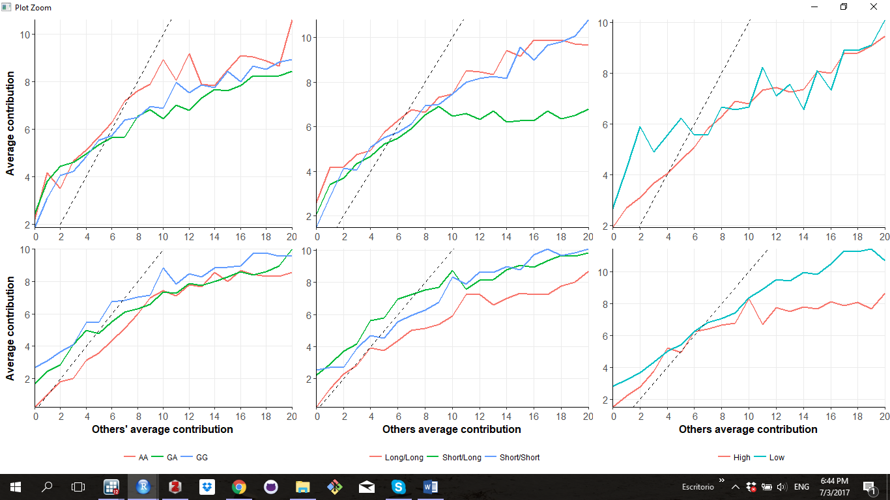scenario (from 14 to 20) (see **Appendix 7** for more detail). However, this result becomes non-significant when corrected for multiple hypothesis testing.

**Figure 3**. Contribution profiles per genotype for OXTR rs53576 (left), AVPR1a RS3 (middle) and MAOA u-VNTR (right) for female (row above) and males (row below).

We also test if genotype has an effect over uninformed contribution; no significant differences in uniformed contributions were found among genotypes neither for females or males (p ≥ 0.19, Kruskal-Wallis, **Appendix 8**).

**General points for discussion**

In general, our results show non-significant association between cooperative strategies and genetic variability for the studied polymorphisms neither for men nor women when strategies where analyze as categorical data. The only significative effect was observed in men for *OXTR* with genotype GG predicting a higher probability of use a OT strategy relative to AA genotype. This result is hard to interpret because OT strategies can represent either cooperative or non-cooperative schemes. Although, it is important to notice that two of the three completely altruistic schemes observed in our entire sample (i.e. Those who contribute 20 tokens in all the others’ contribution scenarios) were displayed by GG males. This, goes in line with previous observations that have found that GG individuals tend to be more prosocial.

Other results, although not significant, go in line with previous observations. For example, we find that men carrying two copies of long alleles in *AVPR1a* RS3 were never classified as FR in our sample and previous studies have shown that relatively short repeats allocated less money to others in a Dictator game. Notably, the contribution profiles obtained when we divided the sample based on genotype for *MAOA* are very similar to the ones observed in Mertins et al., 2013, specially for men.

To our knowledge, this is the first study looking at cooperative strategies in a Latin American sample, applying the FGF, 2001 method. We observed all the previously described cooperative strategies in our sample and replicated the self-serving bias of conditional cooperators.

**References**

1. Fischbacher U, Gächter S, Fehr E. Are people conditionally cooperative? Evidence from a public goods experiment. Econ Lett. 2001 Jun 1;71(3):397–404.

2. Rustagi D, Engel S, Kosfeld M. Conditional Cooperation and Costly Monitoring Explain Success in Forest Commons Management. Science. 2010 Nov 12;330(6006):961–5.

3. Kurzban R, Houser D. Experiments investigating cooperative types in humans: A complement to evolutionary theory and simulations. Proc Natl Acad Sci U S A. 2005 Feb 1;102(5):1803–7.

4. Kocher MG, Cherry T, Kroll S, Netzer RJ, Sutter M. Conditional cooperation on three continents. Econ Lett. 2008 Dec;101(3):175–8.

5. Fischbacher U, Gächter S. Social Preferences, Beliefs, and the Dynamics of Free Riding in Public Goods Experiments. Am Econ Rev. 2010;100(1):541–56.

6. Ellingsen T, Johannesson M, Mollerstrom J, Munkhammar S. Social framing effects: Preferences or beliefs? Games Econ Behav. 2012 Sep 1;76(1):117–30.

7. Fehr E, Fischbacher U. Why Social Preferences Matter – the Impact of Non-Selfish Motives on Competition, Cooperation and Incentives. Econ J. 2002 Mar 1;112(478):C1–33.

8. Peysakhovich A, Nowak MA, Rand DG. Humans Display a “Cooperative Phenotype” that is Domain General and Temporally Stable [Internet]. Rochester, NY: Social Science Research Network; 2014 Aug [cited 2017 Jul 1]. Report No.: ID 2426473. Available from: https://papers.ssrn.com/abstract=2426473

9. Ebstein RP, Israel S, Chew SH, Zhong S, Knafo A. Genetics of Human Social Behavior. Neuron. 2010 Mar;65(6):831–44.

10. Cesarini D, Dawes CT, Fowler JH, Johannesson M, Lichtenstein P, Wallace B. Heritability of cooperative behavior in the trust game. Proc Natl Acad Sci. 2008;105(10):3721–3726.

11. McEwen BB. General Introduction to Vasopressin and Oxytocin: Structure⧸Metabolism, Evolutionary Aspects, Neural Pathway⧸Receptor Distribution, and Functional Aspects Relevant to Memory Processing. Adv Pharmacol. 2004 Jan 1;50:1–50.

12. Kesteren RE van, Tensen CP, Smit AB, Minnen J van, Kolakowski LF, Meyerhof W, et al. Co-evolution of Ligand-Receptor Pairs in the Vasopressin/Oxytocin Superfamily of Bioactive Peptides. J Biol Chem. 1996 Feb 16;271(7):3619–26.

13. Goodson JL, Schrock SE, Klatt JD, Kabelik D, Kingsbury MA. Mesotocin and Nonapeptide Receptors Promote Estrildid Flocking Behavior. Science. 2009 Aug 14;325(5942):862–6.

14. Goodson JL, Bass AH. Vasotocin innervation and modulation of vocal-acoustic circuitry in the teleost Porichthys notatus. J Comp Neurol. 2000 Jul 3;422(3):363–79.

15. Pedersen CA, Ascher JA, Monroe YL, Prange AJ. Oxytocin induces maternal behavior in virgin female rats. Science. 1982 May 7;216(4546):648–50.

16. Pedersen CA, Prange AJ. Induction of maternal behavior in virgin rats after intracerebroventricular administration of oxytocin. Proc Natl Acad Sci. 1979 Dec 1;76(12):6661–5.

17. Williams JR, Insel TR, Harbaugh CR, Carter CS. Oxytocin Administered Centrally Facilitates Formation of a Partner Preference in Female Prairie Voles (Microtus ochrogaster). J Neuroendocrinol. 1994 Jun 1;6(3):247–50.

18. Insel TR, Hulihan TJ. A gender-specific mechanism for pair bonding: Oxytocin and partner preference formation in monogamous voles. Behav Neurosci. 1995;109(4):782–9.

19. Zak PJ, Kurzban R, Matzner WT. Oxytocin is associated with human trustworthiness. Horm Behav. 2005 Dec 1;48(5):522–7.

20. Barraza JA, Zak PJ. Empathy toward Strangers Triggers Oxytocin Release and Subsequent Generosity. Ann N Y Acad Sci. 2009 Jun 1;1167(1):182–9.

21. Kosfeld M, Heinrichs M, Zak PJ, Fischbacher U, Fehr E. Oxytocin increases trust in humans. Nature. 2005 Jun 2;435(7042):673–6.

22. Barraza JA, McCullough ME, Ahmadi S, Zak PJ. Oxytocin infusion increases charitable donations regardless of monetary resources. Horm Behav. 2011 Jul 1;60(2):148–51.

23. Zak PJ, Stanton AA, Ahmadi S. Oxytocin Increases Generosity in Humans. PLOS ONE. 2007 Nov 7;2(11):e1128.

24. Israel S, Weisel O, Ebstein RP, Bornstein G. Oxytocin, but not vasopressin, increases both parochial and universal altruism. Psychoneuroendocrinology. 2012 Aug 1;37(8):1341–4.

25. Rilling JK, DeMarco AC, Hackett PD, Thompson R, Ditzen B, Patel R, et al. Effects of intranasal oxytocin and vasopressin on cooperative behavior and associated brain activity in men. Psychoneuroendocrinology. 2012 Apr 1;37(4):447–61.

26. Rogers RD. The roles of dopamine and serotonin in decision making: evidence from pharmacological experiments in humans. Neuropsychopharmacology. 2011;36(1):114–132.

27. Wood RM, Rilling JK, Sanfey AG, Bhagwagar Z, Rogers RD. Effects of tryptophan depletion on the performance of an iterated Prisoner’s Dilemma game in healthy adults. Neuropsychopharmacology. 2006;31(5):1075–1084.

28. Bilderbeck AC, Brown GDA, Read J, Woolrich M, Cowen PJ, Behrens TEJ, et al. Serotonin and Social Norms: Tryptophan Depletion Impairs Social Comparison and Leads to Resource Depletion in a Multiplayer Harvesting Game. Psychol Sci. 2014 Jul 1;25(7):1303–13.

29. Gong P, Fan H, Liu J, Yang X, Zhang K, Zhou X. Revisiting the impact of OXTR rs53576 on empathy: A population-based study and a meta-analysis. Psychoneuroendocrinology. 2017 Mar 1;80.

30. Lucht MJ, Barnow S, Sonnenfeld C, Rosenberger A, Grabe HJ, Schroeder W, et al. Associations between the oxytocin receptor gene (OXTR) and affect, loneliness and intelligence in normal subjects. Prog Neuropsychopharmacol Biol Psychiatry. 2009 Aug 1;33(5):860–6.

31. Li J, Zhao Y, Li R, Broster LS, Zhou C, Yang S. Association of Oxytocin Receptor Gene (OXTR) rs53576 Polymorphism with Sociality: A Meta-Analysis. PLOS ONE. 2015 Jun 29;10(6):e0131820.

32. Kogan A, Saslow LR, Impett EA, Oveis C, Keltner D, Saturn SR. Thin-slicing study of the oxytocin receptor (OXTR) gene and the evaluation and expression of the prosocial disposition. Proc Natl Acad Sci. 2011 Nov 29;108(48):19189–92.

33. Tost H, Kolachana B, Hakimi S, Lemaitre H, Verchinski BA, Mattay VS, et al. A common allele in the oxytocin receptor gene (OXTR) impacts prosocial temperament and human hypothalamic-limbic structure and function. Proc Natl Acad Sci. 2010 Aug 3;107(31):13936–41.

34. Knafo A, Israel S, Darvasi A, Bachner-Melman R, Uzefovsky F, Cohen L, et al. Individual differences in allocation of funds in the dictator game associated with length of the arginine vasopressin 1a receptor RS3 promoter region and correlation between RS3 length and hippocampal mRNA. Genes Brain Behav. 2008 Apr 1;7(3):266–75.

35. Avinun R, Israel S, Shalev I, Gritsenko I, Bornstein G, Ebstein RP, et al. AVPR1A Variant Associated with Preschoolers’ Lower Altruistic Behavior. PLOS ONE. 2011 Sep 28;6(9):e25274.

36. Levin R, Heresco-Levy U, Bachner-Melman R, Israel S, Shalev I, Ebstein RP. Association between arginine vasopressin 1a receptor (AVPR1a) promoter region polymorphisms and prepulse inhibition. Psychoneuroendocrinology. 2009 Jul 1;34(6):901–8.

37. Wang J, Qin W, Liu F, Liu B, Zhou Y, Jiang T, et al. Sex-specific mediation effect of the right fusiform face area volume on the association between variants in repeat length of AVPR1ARS3 and altruistic behavior in healthy adults. Hum Brain Mapp. 2016 Jul 1;37(7):2700–9.

38. Sabol SZ, Hu S, Hamer D. A functional polymorphism in the monoamine oxidase A gene promoter. Hum Genet. 1998 Sep 1;103(3):273–9.

39. Caspi A, McClay J, Moffitt TE, Mill J, Martin J, Craig IW, et al. Role of Genotype in the Cycle of Violence in Maltreated Children. Science. 2002 Aug 2;297(5582):851–4.

40. Kim-Cohen J, Caspi A, Taylor A, Williams B, Newcombe R, Craig IW, et al. MAOA, maltreatment, and gene–environment interaction predicting children’s mental health: new evidence and a meta-analysis. Mol Psychiatry. 2006 Jun 27;11(10):903–13.

41. McDermott R, Tingley D, Cowden J, Frazzetto G, Johnson DD. Monoamine oxidase A gene (MAOA) predicts behavioral aggression following provocation. Proc Natl Acad Sci. 2009;106(7):2118–2123.

42. Meyer-Lindenberg A, Buckholtz JW, Kolachana B, Hariri AR, Pezawas L, Blasi G, et al. Neural mechanisms of genetic risk for impulsivity and violence in humans. Proc Natl Acad Sci. 2006 Apr 18;103(16):6269–74.

43. Buckholtz JW, Callicott JH, Kolachana B, Hariri AR, Goldberg TE, Genderson M, et al. Genetic variation in MAOA modulates ventromedial prefrontal circuitry mediating individual differences in human personality. Mol Psychiatry. 2007 May 22;13(3):313–24.

44. Mertins V, Schote AB, Hoffeld W, Griessmair M, Meyer J. Genetic Susceptibility for Individual Cooperation Preferences: The Role of Monoamine Oxidase A Gene (MAOA) in the Voluntary Provision of Public Goods. PLOS ONE. 2011 Jun 16;6(6):e20959.

45. Mertins V, Schote AB, Meyer J. Variants of the Monoamine Oxidase A gene (MAOA) predict free-riding behavior in women in a strategic public goods experiment. J Neurosci Psychol Econ. 2013;6(2):97–114.

46. Das M, Das Bhowmik A, Sinha S, Chattopadhyay A, Chaudhuri K, Singh M, et al. MAOA promoter polymorphism and attention deficit hyperactivity disorder (ADHD) in indian children. Am J Med Genet B Neuropsychiatr Genet. 2006 Sep 5;141B(6):637–42.

47. Lyon MF. X-chromosome inactivation. Curr Biol. 1999 Apr 8;9(7):R235–7.

**Appendix**

1. **Instructions of the game**

“Cada jugador deberá ingresar su número identificador en la pantalla de inicio. Este número nos permitirá determinar los pagos de cada jugador de forma anónima. El Pozo común se juega en grupos de cuatro personas formados al azar entre los presentes en la sala. Toda la interacción se dará a través de la red de computadores, y ustedes no sabrán, ni antes ni después del experimento, con qué otras tres personas les tocó jugar.

En el inicio del juego, cada jugador recibe 20 fichas. A continuación, los jugadores deben decidir cuántas fichas conservar para sí y cuántas fichas aportar a un pozo común. Los aportes son anónimos: en el momento de tomar su decisión, ningún jugador conoce cuántas fichas aportaron los demás. Una vez que los jugadores han hecho sus aportes, las fichas del pozo se duplican. Finalmente, el pozo se reparte en partes iguales entre los cuatro miembros del grupo. Es decir, por cada ficha que un jugador aporta al pozo común, ese jugador recupera media ficha y sus tres compañeros de grupo reciben media ficha cada uno. El reparto del pozo común marca el fin del juego. En ese momento las fichas se transforman a su equivalente en pesos, y las ganancias se entregarán en privado a cada jugador al salir de la sala.

Una vez finalizado el juego, los jugadores canjean sus fichas por dinero. Las fichas valen 250 pesos cada una. Un jugador puede ganar entre 2.500 y 12.500 pesos en el juego, dependiendo de su aporte al pozo común y del aporte de sus compañeros de grupo. Los aportes al pozo se mantienen anónimos incluso después del juego. Ni siquiera los investigadores podrán identificar los aportes de cada jugador. El siguiente es un ejemplo de juego:

Si se aportan 36 fichas en total al pozo común, serán duplicadas a 72. Luego se reparten entre los 4 jugadores del grupo lo que da un total de 18 fichas para cada uno, entonces:

|  |  |  |  |  |  |
| --- | --- | --- | --- | --- | --- |
| **Jugador** | **Fichas aportadas** | **Fichas conservadas** | **Fichas obtenidas del pozo común** | **Fichas totales** | **Pago ($)** |
| A | 0 | 20 | 18 | 38 | 9.500 |
| B | 19 | 1 | 18 | 19 | 4.750 |
| C | 6 | 14 | 18 | 32 | 8.000 |
| D | 11 | 9 | 18 | 27 | 6.750 |

En este juego los miembros del grupo no jugarán de manera simultánea. Tres miembros, elegidos al azar por el computador, serán designados jugadores desinformados y juegan primero, sin conocer los aportes de los demás. El miembro restante es designado jugador informado y juega en segundo lugar, conociendo el aporte promedio (no individual) de los tres jugadores desinformados. Por lo tanto, el jugador informado puede condicionar su aporte a la contribución promedio de sus compañeros de grupo.

La decisión del contribuyente informado no es un número sino un plan. Por ejemplo, el plan de un jugador informado podría ser el siguiente:

Si mis compañeros aportan en promedio 0 fichas, yo aportaré 1 ficha.

Si mis compañeros aportan en promedio 2 fichas, yo aportaré 15 fichas

Si mis compañeros aportan en promedio 4 fichas, yo aportaré 7 fichas.

….

Si mis compañeros aportan en promedio 20 fichas, yo aportaré 3 fichas.

Imaginemos que los jugadores desinformados aportan 1, 6 y 5 fichas al proyecto, respectivamente. Esto da un aporte promedio de 4 fichas. De acuerdo con el plan anterior, el jugador informado aportará 7 fichas. Por lo tanto, el aporte total del grupo es 1 + 6 + 5 + 7 = 19 fichas. Estas se duplican a 38 fichas. Divididas por cuatro, cada jugador obtiene 9,5 fichas. Estas se aproximan a 10 fichas. Como el jugador informado conservó 13 fichas, su ganancia final son 13 + 10= 23 fichas, y su pago en dinero es 23 × 250 = 5.750 pesos.

La última regla de Pozo Común es que, en el momento de tomar sus decisiones, ningún jugador sabe qué rol tendrá en el juego por lo que jugará en ambos roles y luego será designado jugador informado o desinformado de manera aleatoria por el computador. Para esto deberá responder dos preguntas:

1. Cuántas fichas aportará si es designado jugador desinformado:

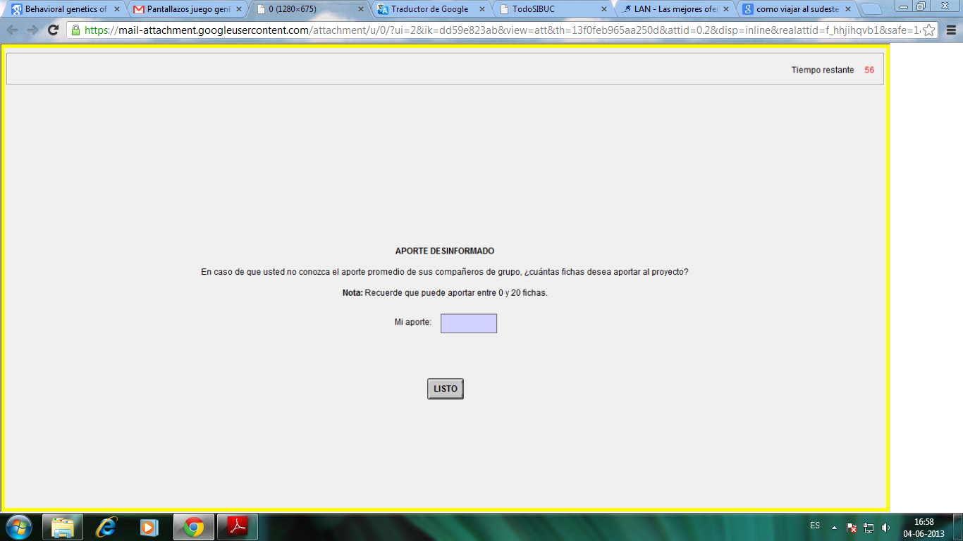

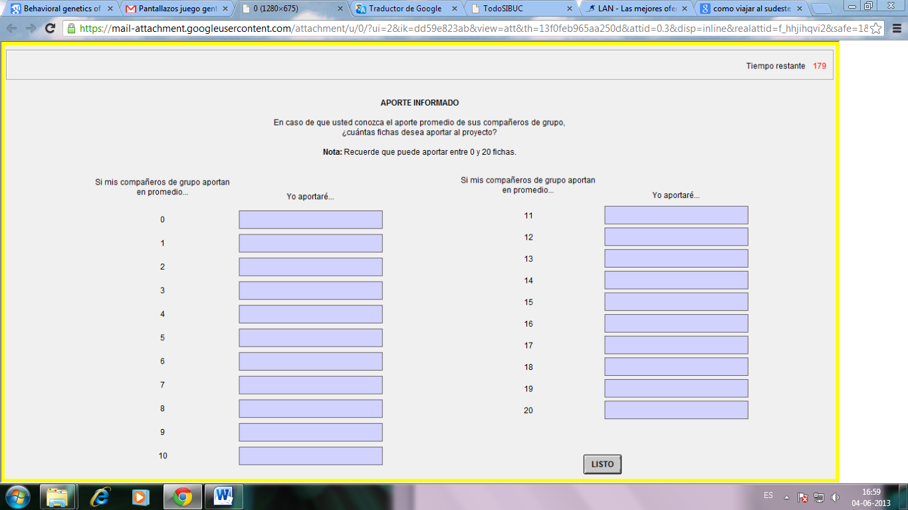2. Cuál será su plan si es designado jugador informado:

Para avanzar en el juego apreté el botón “Listo” con el mouse. No es posible volver atrás una vez realizada esta acción.

Recuerde guardar estricto silencio durante todo el experimento.”

1. ***AVPR1a* RS3 allele’s frequencies and classification depending on length.**

|  |  |  |
| --- | --- | --- |
| Allele (bp) | Frequency | Length classification |
| 324 | 5 | Short |
| 325 | 2 |
| 326 | 1 |
| 331 | 1 |
| 333 | 1 |
| 334 | 1 |
| 335 | 18 |
| 337 | 23 |
| 338 | 2 |
| 339 | 80 |
| 341 | 72 |
| 342 | 1 | Long |
| 343 | 38 |
| 344 | 1 |
| 345 | 58 |
| 346 | 1 |
| 347 | 21 |
| 348 | 5 |
| 349 | 2 |
| 351 | 18 |
| 352 | 3 |
| 353 | 10 |
| 354 | 5 |
| 356 | 1 |

1. **u-VNTR *MAOA* allele’s frequencies**.

|  |  |
| --- | --- |
| Allele (number of repeats) | Frequency |
| 3.5 | 92 |
| 4.5 | 158 |
| 5.5 | 3 |
| 6.5 | 1 |

1. **Results for the Fisher exact test used to analyze the association between cooperative disposition and genotype by gender**.

|  |  |  |
| --- | --- | --- |
| **Polymorphism** | **p-value for women** | **p-value for men** |
| *OXTR* rs53576 | 0.996 | 0.153 |
| *AVPR1a* RS3 | 0.144 | 0.554 |
| *MAOA* u-vntr | 0.929 | 0.925 |

1. **Marginal effects of genotype on cooperative preferences for women.** Obtained from the bootstrapped multinomial logistical regression model with cooperative preference as dependent variable and genotype as explaining variable. For *OXTR rs53567* AA genotype is the baseline (n=104), for *AVPR1* RS3 Long/Long genotype is the baseline (n=106), and for *MAOA* u-VNTR, the baseline is the MAOA-L variant (n=47).

|  |  |  |  |
| --- | --- | --- | --- |
| **Cooperative preference** | ***OXTR* rs53567 genotype** | **Marginal effect (dy/dx)** | **p-value** |
| FR | AG | -0.006 | 0.987 |
| GG | -0.028 | 0.947 |
| CC | AG | 0.058 | 0.875 |
| GG | 0.069 | 0.857 |
| HS | AG | -0.006 | 0.991 |
| GG | 0.014 | 0.978 |
| OT | AG | -0.047 | 0.866 |
| GG | -0.056 | 0.856 |

|  |  |  |  |
| --- | --- | --- | --- |
| **Cooperative preference** | ***AVPR1a* RS3 genotype** | **Marginal effect (dy/dx)** | **p-value** |
| FR | Long/Short | 0.026 | 0.942 |
| Short/Short | 0.045 | 0.919 |
| CC | Long/Short | -0.067 | 0.790 |
| Short/Short | 0.095 | 0.773 |
| HS | Long/Short | 0.169 | 0.604 |
| Short/Short | -0.040 | 0.917 |
| OT | Long/Short | -0.128 | 0.655 |
| Short/Short | -0.099 | 0.717 |

|  |  |  |  |
| --- | --- | --- | --- |
| **Cooperative preference** | ***MAOA* u-vntr genotype** | **Marginal effect (dy/dx)** | **p-value** |
| FR | High expression | -0.006 | 0.993 |
| CC | High expression | 0.082 | 0.917 |
| **HS** | **High expression** | **0.0790** | **0.035** |
| OT | High expression | -0.155 | 0.856 |

1. **Marginal effects of genotype over cooperative preferences for men.** Obtained from the bootstrapped multinomial logistical regression model with cooperative preference as dependent variable and genotype as the explaining variable. For *OXTR rs53567* AA genotype is the baseline (n=78), for *AVPR1* RS3 Long/Long genotype is the baseline (n=79) and for *MAOA* u-VNTR the baseline is the MAOA -L variant (n= 71).

|  |  |  |  |
| --- | --- | --- | --- |
| **Cooperative preference** | ***OXTR* rs53567 genotype** | **Marginal effect (dy/dx)** | **p-value** |
| FR | AG | 0.061 | 0.940 |
| GG | -0.061 | 0.941 |
| CC | AG | -0.115 | 0.919 |
| GG | -0.167 | 0.884 |
| HS | AG | -0.119 | 0.913 |
| GG | -0.122 | 0.908 |
| OT | AG | 0.172 | 0.060 |
| **GG** | **0.350** | **0.002** |

|  |  |  |  |
| --- | --- | --- | --- |
| **Cooperative preference** | ***AVPR1a* RS3 genotype** | **Marginal effect (dy/dx)** | **p-value** |
| FR | **Long/Short** | **0.158** | **0.027** |
| Short/Short | 0.071 | 0.816 |
| CC | Long/Short | 0.065 | 0.874 |
| Short/Short | 0.146 | 0.804 |
| HS | Long/Short | -0.152 | 0.800 |
| Short/Short | -0.124 | 0.849 |
| OT | Long/Short | -0.071 | 0.790 |
| Short/Short | -0.093 | 0.846 |

|  |  |  |  |
| --- | --- | --- | --- |
| **Cooperative preference** | ***MAOA* u-vntr genotype** | **Marginal effect (dy/dx)** | **p-value** |
| FR | High expression | -0.022 | 0.960 |
| CC | High expression | 0.002 | 0.997 |
| HS | High expression | 0.053 | 0.878 |
| OT | High expression | -0.034 | 0.842 |

1. **Kruskal-Wallis test used to test for significant differences in contribution level among genotypes in different contribution scenarios.** We divided others’ contributions into three rough categories (low contributions scenario: 0–6, mid contributions scenario: 7– 13 and high contributions scenario: 14–20) following Mertins et al., 2013. Estimations with 2 degrees of freedom for *OXTR* rs53576 and *AVPR1a* RS3 and 1 for *MAOA* u-VNTR. The table above shows results for women and the one below for men.

|  |  |  |  |  |  |  |
| --- | --- | --- | --- | --- | --- | --- |
| **Polymorphism** | **Low contribution scenario** | | **Mid contribution scenario** | | **High contribution scenario** | |
| $$X^{2}$$ | p-value | $$X^{2}$$ | p-value | $$X^{2}$$ | p-value |
| *OXTR* rs53576 | 0.022 | 0.989 | 2.041 | 0.360 | 0.568 | 0.753 |
| *AVPR1a* RS3 | 0.803 | 0.669 | 1.482 | 0.477 | 7.313 | **0.0258** |
| *MAOA* u-VNTR | 0.536 | 0.765 | 0.428 | 0.807 | 2.952 | 0.229 |

|  |  |  |  |  |  |  |
| --- | --- | --- | --- | --- | --- | --- |
| **Polymorphism** | **Low contribution scenario** | | **Mid contribution scenario** | | **High contribution scenario** | |
| $$X^{2}$$ | p-value | $$X^{2}$$ | p-value | $$X^{2}$$ | p-value |
| *OXTR* rs53576 | 3.549 | 0.170 | 0.959 | 0.619 | 0.368 | 0.832 |
| *AVPR1a* RS3 | 0.549 | 0.760 | 1.555 | 0.460 | 0.876 | 0.645 |
| *MAOA* u-VNTR | 0.025 | 0.876 | 1.413 | 0.235 | 2.637 | 0.104 |

1. **Kruskal-Wallis test to analyze significant differences in uniformed contribution among genotypes.** Estimations with 2 degrees of freedom for OXTR rs53576 and AVPR1a RS3 and 1 for MAOA u-VNTR.

|  |  |  |  |  |
| --- | --- | --- | --- | --- |
| **Polymorphism** | **Females** | | **Males** | |
|  | $$X^{2}$$ | p-value | $$X^{2}$$ | p-value |
| *OXTR* rs53576 | 1.038 | 0.5951 | 2.250 | 0.3246 |
| *AVPR1a* RS3 | 0.613 | 0.7359 | 0.771 | 0.6802 |
| *MAOA* u-vntr | 1.755 | 0.1852 | 0.155 | 0.6935 |